New Biogas Purification Method Produces Renewable Natural Gas (RNG)
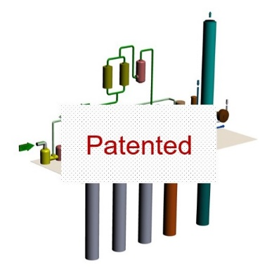
Patented Biogas Water Wash Method

- ETI’s new patented method may prove to be the lowest cost biogas upgrading process for producing Renewable Natural Gas (RNG) available in the market today. With this innovative method, capital cost savings of 30% or more may be realized as compared to other biogas upgrading systems.

- Plans are now being made to commercialize this innovative biogas purification method that uses proven biogas separation technology in a novel lower cost process.

Basic Technology and Benefits

- Our new patented method is based on proven operating technology used at biogas sites around the world but ETI’s lower cost process has the potential to be an “economic biogas game changer”.

- This innovative gas separation approach uses water as a natural solvent that readily absorbs carbon dioxide (CO2) and other trace contaminants such as hydrogen sulfide (H2S) and siloxanes resulting in a purified methane supply of RNG.

- Variables involved in this biogas water wash process are dependent on flow, pressure, temperature and the time necessary for the absorption process to occur. ETI’s absorption efficiency of CO2 and H2S increases similarly with higher pressure and colder water temperature.

- Once the biogas is upgraded, the RNG can be used seamlessly as a replacement for natural gas in thermal processes, electricity generation, natural gas pipeline injection and even compressed gas for high value vehicle fuel.

- This new process is modular and scalable, making it applicable for smaller systems which were not previously cost effective.

- This biogas upgrading process can be utilized at all biogas producing sites; WWTP’s, Ag digesters landfills and other methane sources. This process can also be arranged in parallel and series configurations to increase flow and/or purity of methane product gas.

- This biogas water wash is categorized as a very “Green - sustainable process” by industry experts that even allows the potential beneficial use of the CO2 by-product in some cases.

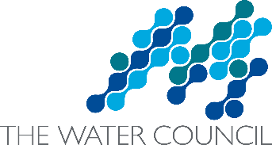
For more information contact:
Bryan Johnson, P.E. – Founder/President
Energy Tech Innovations, LLC
Energy Tech Innovations is a 2016 winner of The Water Council’s BREW Accelerator. View our water technology startup portfolio at www.thewatercouncil.com
bjohnsonwi@gmail.com
Cell: 262-844-6401

